13.1 Data:
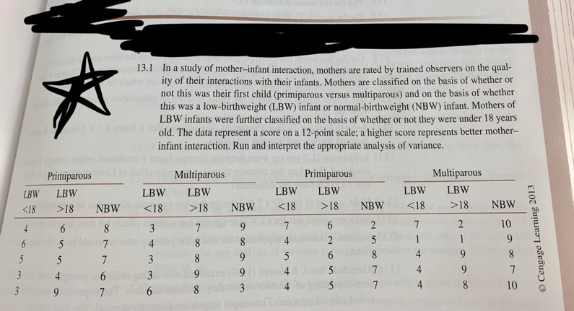

Questions: Answer each part using data from Exercise 13.1 in Howell:

- Rearrange the data in a table similar to Table 13.4-a (p. 421), showing cell means, each factor’s marginal means, and the grand mean (i.e., overall mean). You don’t need to include the raw data in the table.
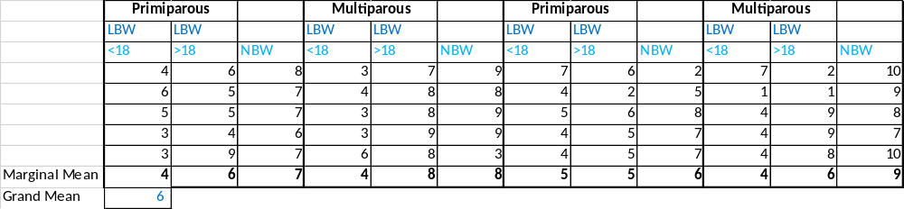

- Use Excel, Word, or R (but not using SPSS) to construct a plot that has Birth Weight on the horizontal axis and separate lines for the two levels of Parity. The plot should contain both the cell means and marginal means, and the lines should be meaningfully labeled (e.g., primiparous).

- Complete the following ANOVA table by hand computation. Please show your work.

Source | df | SS | MS | F | Critical Value  ($α=.05$)
Parity | dfbetween​=2−1=1 | SSwithin​=∑SSwithingroups​=45.8+146.8=192.6 | MSbetween​=dfbetween​SSbetween​​=12.5​=2.5 | F=MSwithin​MSbetween​​=5.0682.5​=0.493 | the significance level is α=0.05, and the degrees of freedom are df_1 = 1 and df_2 = 1df2​=1, therefore, the rejection region for this F-test is R={F:F>Fc​=4.098}
Birth Weight | dfwithin​=dftotal​−dfbetween​=39−1=38 | SStotal​=i,j∑​Xij2​−N1​(i,j∑​Xij​)2=1256−402062​=195.1 | MSwithin​=dfwithin​SSwithin​​=38192.6​=5.068 | =0.493 | the significance level is α=0.05, and the degrees of freedom are df_1 = 1 and df_2 = 1df2​=1, therefore, the rejection region for this F-test is R={F:F>Fc​=4.098}
Interaction | =19-1=18 | ​=45.8+146.8=192.6 | ​=2.5 | =92.6/2.5=0.50 | =4.1,based on the DF and 0.05 level of significance
Error |  | 210.400
Total | dftotal​=40−1=39 | 338.933

- [SPSS] Run ANOVA analysis using SPSS. Please rename the dummy variables related to each factor appropriately prior to running the analysis. Copy and paste the ANOVA table and highlight the rows that correspond to the ones in Part c. Also, copy and paste the summary table and label the cell means, marginal means, and grand mean using the statistical notation in your textbook. For labeling, consider using callouts (i.e., speech bubbles).

ANOVA
Multiparous
 | Sum of Squares | df | Mean Square | F | Sig.
Between Groups | 47.167 | 6 | 7.861 | 1.026 | .451
Within Groups | 99.633 | 13 | 7.664
Total | 146.800 | 19

Robust Tests of Equality of Means^{b}
Multiparous
 | Statisticª | df1 | df2 | Sig.
Welch | . | . | . | .
Brown-Forsythe | . | . | . | .
a. Asymptotically F distributed.
b. Robust tests of equality of means cannot be performed for Multiparous because at least one group has the sum of case weights less than or equal to 1.

Means Plots

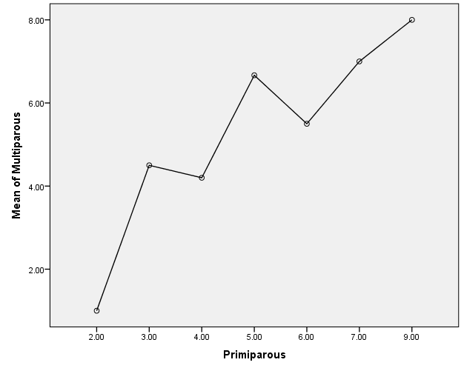

- [SPSS] Use simple effects to compare the three groups of multiparous mothers and report the appropriate statistics (use $α=.05)$. What conclusions can you draw from this analysis?

Estimated Marginal Means

1. Grand Mean
Dependent Variable: Less_18
Mean | Std. Error | 95% Confidence Interval
Mean | Std. Error | Lower Bound | Upper Bound
3.900ª | . | . | .
a. Based on modified population marginal mean.

Estimates
Dependent Variable: Less_18
Great_18 | Mean | Std. Error | 95% Confidence Interval
Great_18 | Mean | Std. Error | Lower Bound | Upper Bound
1.00 | 1.000ª | . | . | .
2.00 | 7.000ª | . | . | .
7.00 | 3.000ª | . | . | .
8.00 | 4.250ª | . | . | .
9.00 | 3.667ª | . | . | .
a. Based on modified population marginal mean.

Pairwise Comparisons
Dependent Variable: Less_18
(I) Great_18 | (J) Great_18 | Mean Difference (I-J) | Std. Error | Sig.^{c} | 95% Confidence Interval for Difference^{c}
 |  |  |  |  | Lower Bound | Upper Bound
1.00 | 2.00 | -6.000^{a,b} | . | . | . | .
1.00 | 7.00 | -2.000^{a,b} | . | . | . | .
1.00 | 8.00 | -3.250^{a,b} | . | . | . | .
1.00 | 9.00 | -2.667^{a,b} | . | . | . | .
2.00 | 1.00 | 6.000^{a,b} | . | . | . | .
2.00 | 7.00 | 4.000^{a,b} | . | . | . | .
2.00 | 8.00 | 2.750^{a,b} | . | . | . | .
2.00 | 9.00 | 3.333^{a,b} | . | . | . | .
7.00 | 1.00 | 2.000^{a,b} | . | . | . | .
7.00 | 2.00 | -4.000^{a,b} | . | . | . | .
7.00 | 8.00 | -1.250^{a,b} | . | . | . | .
7.00 | 9.00 | -.667^{a,b} | . | . | . | .
8.00 | 1.00 | 3.250^{a,b} | . | . | . | .
8.00 | 2.00 | -2.750^{a,b} | . | . | . | .
8.00 | 7.00 | 1.250^{a,b} | . | . | . | .
8.00 | 9.00 | .583^{a,b} | . | . | . | .
9.00 | 1.00 | 2.667^{a,b} | . | . | . | .
9.00 | 2.00 | -3.333^{a,b} | . | . | . | .
9.00 | 7.00 | .667^{a,b} | . | . | . | .
9.00 | 8.00 | -.583^{a,b} | . | . | . | .
Based on estimated marginal means
a. An estimate of the modified population marginal mean (I).
b. An estimate of the modified population marginal mean (J).
c. Adjustment for multiple comparisons: Least Significant Difference (equivalent to no adjustments).

Univariate Tests
Dependent Variable: Less_18
 | Sum of Squares | df | Mean Square | F | Sig. | Partial Eta Squared
Contrast | 19.483 | 4 | 4.871 | . | . | 1.000
Error | .000 | 0 | .
The F tests the effect of Great_18. This test is based on the linearly independent pairwise comparisons among the estimated marginal means.

Estimates
Dependent Variable: Less_18
NBW | Mean | Std. Error | 95% Confidence Interval
NBW | Mean | Std. Error | Lower Bound | Upper Bound
3.00 | 6.000ª | . | . | .
7.00 | 4.000ª | . | . | .
8.00 | 4.000ª | . | . | .
9.00 | 2.500ª | . | . | .
10.00 | 5.500ª | . | . | .
a. Based on modified population marginal mean.

Pairwise Comparisons
Dependent Variable: Less_18
(I) NBW | (J) NBW | Mean Difference (I-J) | Std. Error | Sig.^{c} | 95% Confidence Interval for Difference^{c}
 |  |  |  |  | Lower Bound | Upper Bound
3.00 | 7.00 | 2.000^{a,b} | . | . | . | .
3.00 | 8.00 | 2.000^{a,b} | . | . | . | .
3.00 | 9.00 | 3.500^{a,b} | . | . | . | .
3.00 | 10.00 | .500^{a,b} | . | . | . | .
7.00 | 3.00 | -2.000^{a,b} | . | . | . | .
7.00 | 8.00 | -2.815E-016^{a,b} | . | . | . | .
7.00 | 9.00 | 1.500^{a,b} | . | . | . | .
7.00 | 10.00 | -1.500^{a,b} | . | . | . | .
8.00 | 3.00 | -2.000^{a,b} | . | . | . | .
8.00 | 7.00 | 2.815E-016^{a,b} | . | . | . | .
8.00 | 9.00 | 1.500^{a,b} | . | . | . | .
8.00 | 10.00 | -1.500^{a,b} | . | . | . | .
9.00 | 3.00 | -3.500^{a,b} | . | . | . | .
9.00 | 7.00 | -1.500^{a,b} | . | . | . | .
9.00 | 8.00 | -1.500^{a,b} | . | . | . | .
9.00 | 10.00 | -3.000^{a,b} | . | . | . | .
10.00 | 3.00 | -.500^{a,b} | . | . | . | .
10.00 | 7.00 | 1.500^{a,b} | . | . | . | .
10.00 | 8.00 | 1.500^{a,b} | . | . | . | .
10.00 | 9.00 | 3.000^{a,b} | . | . | . | .
Based on estimated marginal means
a. An estimate of the modified population marginal mean (I).
b. An estimate of the modified population marginal mean (J).
c. Adjustment for multiple comparisons: Least Significant Difference (equivalent to no adjustments).

Univariate Tests
Dependent Variable: Less_18
 | Sum of Squares | df | Mean Square | F | Sig. | Partial Eta Squared
Contrast | 17.400 | 4 | 4.350 | . | . | 1.000
Error | .000 | 0 | .
The F tests the effect of NBW. This test is based on the linearly independent pairwise comparisons among the estimated marginal means.

Dependent Variable: Less_18
Great_18 | NBW | Mean | Std. Error | 95% Confidence Interval
 |  |  |  | Lower Bound | Upper Bound
1.00 | 3.00 | .ª | . | . | .
1.00 | 7.00 | .ª | . | . | .
1.00 | 8.00 | .ª | . | . | .
1.00 | 9.00 | 1.000 | . | . | .
1.00 | 10.00 | .ª | . | . | .
2.00 | 3.00 | .ª | . | . | .
2.00 | 7.00 | .ª | . | . | .
2.00 | 8.00 | .ª | . | . | .
2.00 | 9.00 | .ª | . | . | .
2.00 | 10.00 | 7.000 | . | . | .
7.00 | 3.00 | .ª | . | . | .
7.00 | 7.00 | .ª | . | . | .
7.00 | 8.00 | .ª | . | . | .
7.00 | 9.00 | 3.000 | . | . | .
7.00 | 10.00 | .ª | . | . | .
8.00 | 3.00 | 6.000 | . | . | .
8.00 | 7.00 | .ª | . | . | .
8.00 | 8.00 | 4.000 | . | . | .
8.00 | 9.00 | 3.000 | . | . | .
8.00 | 10.00 | 4.000 | . | . | .
9.00 | 3.00 | .ª | . | . | .
9.00 | 7.00 | 4.000 | . | . | .
9.00 | 8.00 | 4.000 | . | . | .
9.00 | 9.00 | 3.000 | . | . | .
9.00 | 10.00 | .ª | . | . | .
a. This level combination of factors is not observed, thus the corresponding population marginal mean is not estimable.
Based on ANOVA, there is no significant interaction (P = 0.69), and the main groups under the study are both significant (P < 0.01). The output above shows the mean relative weights of the two groups of Children. The only comparison which is not clear is that between <18 and >18 mean weights and differences between all other means are significant. Therefore, we use the t test, which allows us to determine if there is any difference between the groups means under the study. This is exactly what we are interested in, and from the post hoc t test, there is no statistically significant difference (P = 0.997) between these two group means. T

- [SPSS] Conduct all pairwise comparisons among the means of the three groups of multiparous mothers. Make sure the familywise error rate does not exceed $α=.05$ with the Bonferroni correction. Copy and paste the relevant SPSS outputs and interpret your results.

Pairwise Comparisons
Dependent Variable: Less_18
(I) NBW | (J) NBW | Mean Difference (I-J) | Std. Error | Sig.^{c} | 95% Confidence Interval for Difference^{c}
 |  |  |  |  | Lower Bound | Upper Bound
3.00 | 7.00 | 2.000^{a,b} | . | . | . | .
3.00 | 8.00 | 2.000^{a,b} | . | . | . | .
3.00 | 9.00 | 3.500^{a,b} | . | . | . | .
3.00 | 10.00 | .500^{a,b} | . | . | . | .
7.00 | 3.00 | -2.000^{a,b} | . | . | . | .
7.00 | 8.00 | -2.815E-016^{a,b} | . | . | . | .
7.00 | 9.00 | 1.500^{a,b} | . | . | . | .
7.00 | 10.00 | -1.500^{a,b} | . | . | . | .
8.00 | 3.00 | -2.000^{a,b} | . | . | . | .
8.00 | 7.00 | 2.815E-016^{a,b} | . | . | . | .
8.00 | 9.00 | 1.500^{a,b} | . | . | . | .
8.00 | 10.00 | -1.500^{a,b} | . | . | . | .
9.00 | 3.00 | -3.500^{a,b} | . | . | . | .
9.00 | 7.00 | -1.500^{a,b} | . | . | . | .
9.00 | 8.00 | -1.500^{a,b} | . | . | . | .
9.00 | 10.00 | -3.000^{a,b} | . | . | . | .
10.00 | 3.00 | -.500^{a,b} | . | . | . | .
10.00 | 7.00 | 1.500^{a,b} | . | . | . | .
10.00 | 8.00 | 1.500^{a,b} | . | . | . | .
10.00 | 9.00 | 3.000^{a,b} | . | . | . | .
Based on estimated marginal means
a. An estimate of the modified population marginal mean (I).
b. An estimate of the modified population marginal mean (J).
c. Adjustment for multiple comparisons: Least Significant Difference (equivalent to no adjustments).
Since the p-value for F-statistic is greater than 0.05 we conclude there is significant difference in the pairwise means for the groups.

- By taking into account the various pieces of information from your analysis, what statistical conclusions can you draw from the study? Provide a full write-up in which you interpret all of the findings.

From the visual-display and descriptive statistics there is a trend differences in the means of the groups.
We can conclude that there is significant differences between the means of the groups as indicated by the ANOVA analysis. Based on ANOVA, there is no significant interaction (P = 0.69), and the main groups under the study are both significant (P < 0.01). The output above shows the mean relative weights of the two groups of Children.

The effect on the sample size is insignificant based on the eta squared statistics. The only comparison which is not clear is that between <18 and >18 mean weights and differences between all other means are significant. Therefore, we use the t test, which allows us to determine if there is any difference between the group’s means under the study. This is exactly what we are interested in, and from the post hoc t test, there is no statistically significant difference (P = 0.997) between these two group means

- Compute partial ${\hat{η}}^{2}$ for the effect of interaction by hand and explain its meaning.
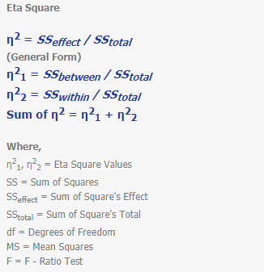
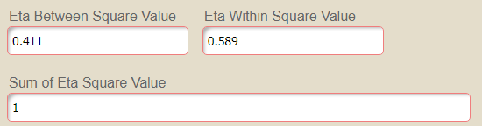

Since the sum of eta sq. tends to one, we conclude that there is no significant effect on the sample size in our research.
- [GPower] Compute the power for interaction using the computer package GPower. Include a screenshot (not a picture from your phone) of G Power that clearly shows the inputs and outputs. Interpret the result.
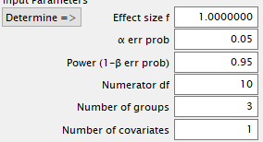
Power analysis indicated a 95% chance of detecting a large effect
size and a 5% chance of detecting a medium effect size, as .8 and .5 of a population standard deviation between the means respectively) between the two groups as significant at the 5% level (two tailed).

